

**OFFICE OF THE PRESIDENT**

**TO : ALL CONCERNED August 7, 2020**

**SUBJECT : NOMENCLATURE OF THE DIFFERENT COLLEGES**

As approved by the School Board, we would like to inform you that the nomenclature of the different colleges shall be changed/updated effective AY 2020-2021; to wit:

1. From College of Arts & Sciences to **School of Arts and Sciences**
2. From College of Education to **School of Education**
3. From College of Engineering to **School of Engineering**
4. From College of Commerce to **School of Business & Management**
5. From College of Information, Communication & Computer technology to **School of** **Computer Studies**
6. From College of Nursing to **School of Allied Medical Sciences**

Please be guided accordingly.

Thank you.

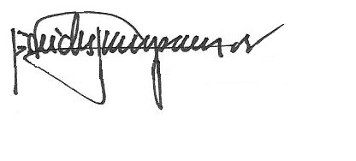

REV. FR. CRISTOPHER C. MASPARA, OAR

President

/bvs